**Payroll Application User Manual**

**Summary:**

This application is for computing payroll expenses; it computes payroll amounts for Employee Federal Withholding, Employee State Withholding, Employee Social Security Tax, Employee Medicare Tax, Employee California State Disability (SDI/VDI), Employee 401(K), Company Social Security, Company Medicare, Company State FUTA.

**Future enhancement/Limitation:**

Right now, it does not support imputed income due to company employee insurance coverage above 50K, and Medical and Dental insurance premium paid by employee. These features will be added in due course along with the support for other states. Employees working more than 40 hours per week are assumed to get paid at their standard rate; no overtime rate is charged. User entered data is stored in SQLiteDB file, one file per company, since the database is not secure the software does not store security number, etc. In future secure database version will be used.

**The software is free to use for business, commercial and personal use, distributed under MIT license. User of the software assumes all liabilities.**

**Contact**: Please send your comments to the author email: **companypayrollapp@gmail.com**

**Installation**:

Download the Payroll.Zip file and unzip to a directory, for example C:\Payroll.

Contents of Payroll directory after unzipping

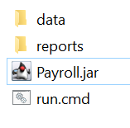

data – directory contains files for computing payroll taxes, plan is to update the files every year.

reports - directory contains CSV report generated by the application.

run.cmd --- Batch file for running Payroll application

Payroll.jar – Java main application jar file.

**Pre-requisite to running the application**: Java run time environment is installed on the computer

**How to Use the Application**

1. **Run the application**

Double click on run.cmd to run the application; if you have problem starting up please edit the file run.cmd in notepad and modify the line from “start javaw -jar Payroll.jar” to

“start C:*YourDirectoryWhereJavawIsLocated*\javaw -jar Payroll.jar”

1. Application startup screen as shown below will be shown

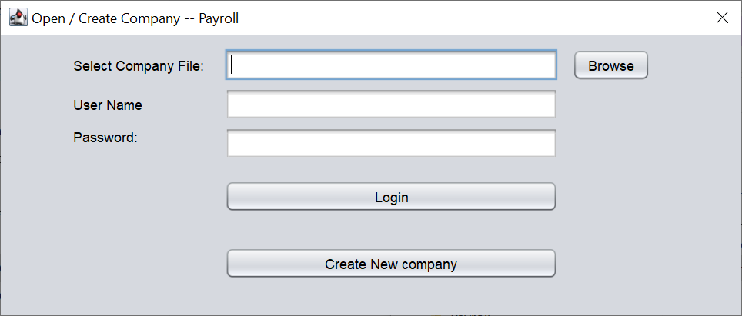

1. **Create company file for saving payroll information (one time action).**

If you are using the software for first time, we need to create a database file for storing company information. We need to create one file per company. Please press the “Create New Company” button.

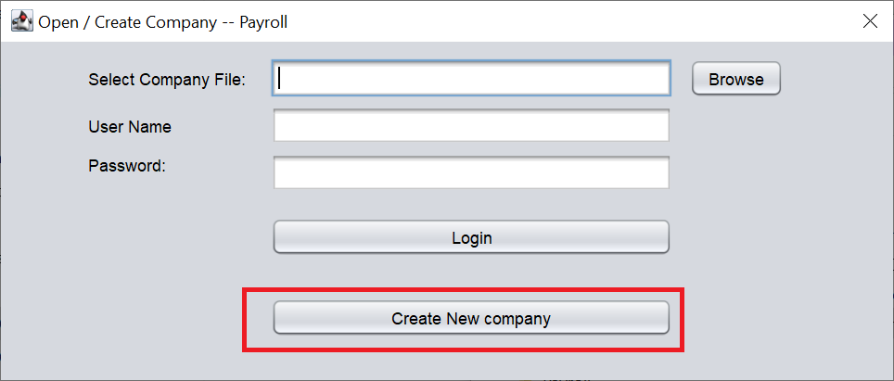

1. Enter company information and press OK.
2. 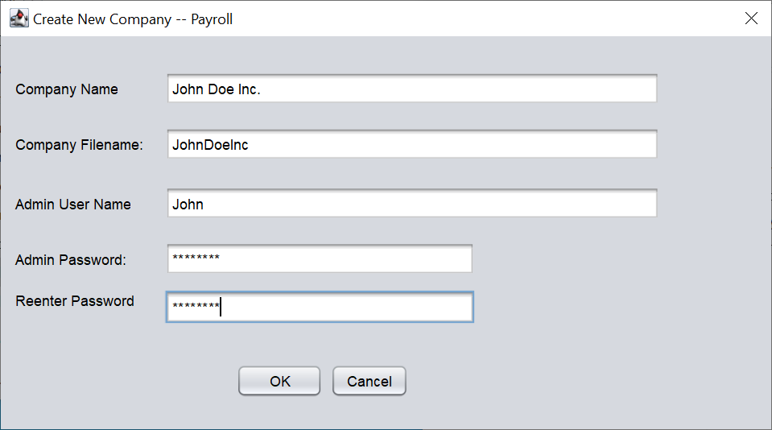
3. Company file is created
4. 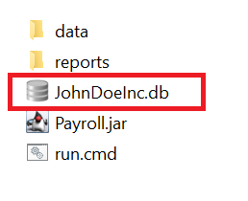
5. Select the company file and login to the application.

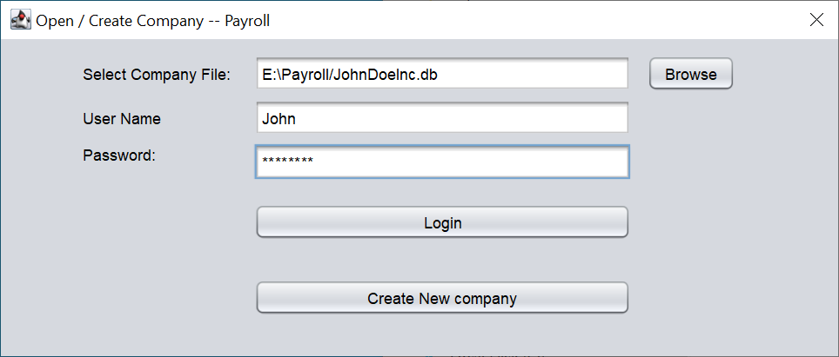

1. Main application screen as shown below is displayed.

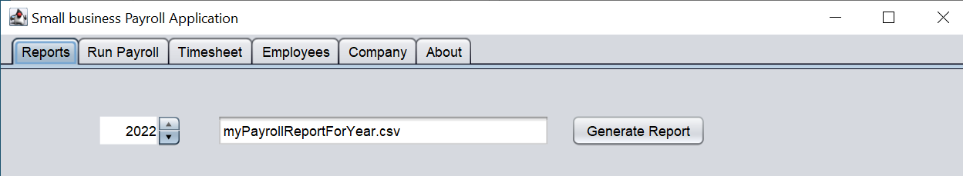

1. Click on the “Company” tab to enter information that is applicable to company or all employees of the company.

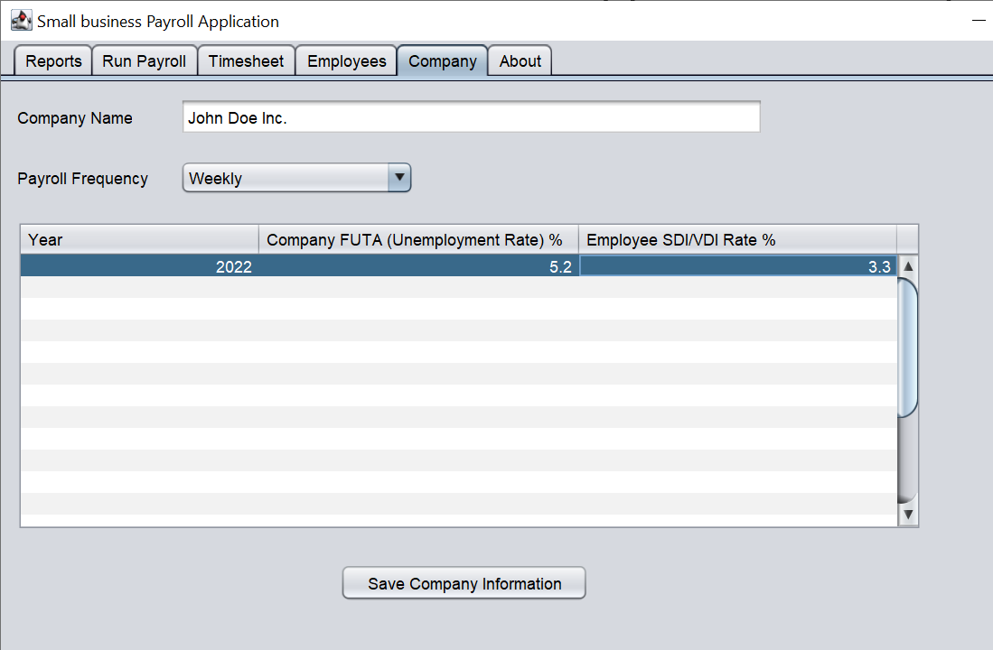

**Important: Please hit enter to commit the changes in table grid for the last edited cell, if you do not hit enter the contents of cell will not get “set” and wrong value will be saved in data base.**

1. Press “Save Company Information” to update the company database with the values entered in UI.
2. Click on the “Employee” tab to enter company employees, their hourly salary, 401(K) deferral percentage rate, W-4 and CA DE-4 information.
3. Enter employee information.
4. 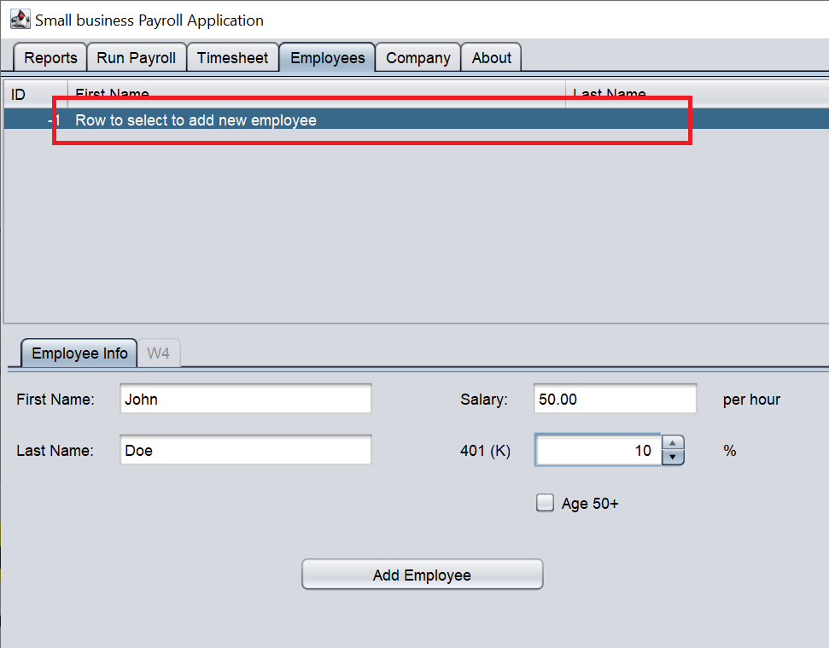
5. Convert employee paid annual salary to hourly rate as follows

Annual Salary/(260 X 8)

For example, employee with 50K per year salary will have hourly rate as 50,000/(260*8) = $24.04 per hour

1. After an employee is added select the employee and update Employee information and W4/DE4 information.
2. 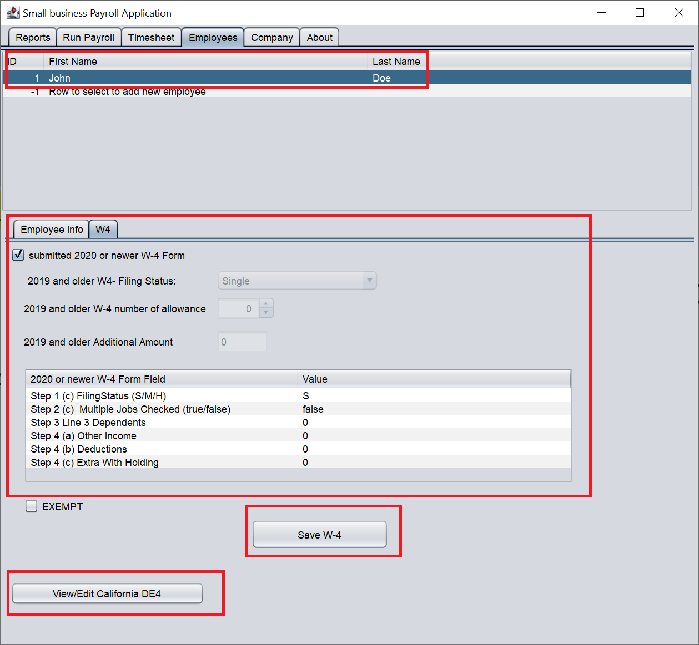
3. For new 2020+ W4 form enter the Filling status as S for Single, M for Married and H for head of house hold.
4. **Important: Please hit enter to commit the changes in table grid for the last edited cell**
5. Save W-4 form changes by presses the “Save W-4” button.
6. If employee has submitted DE-4 form press the “View/Edit California DE4” button to view or update DE-4 form entry.
7. 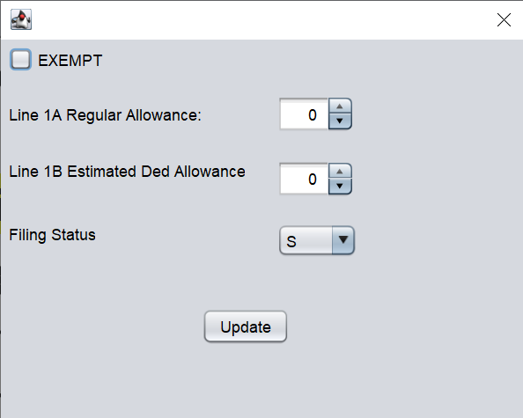
8. Add all the employees
9. 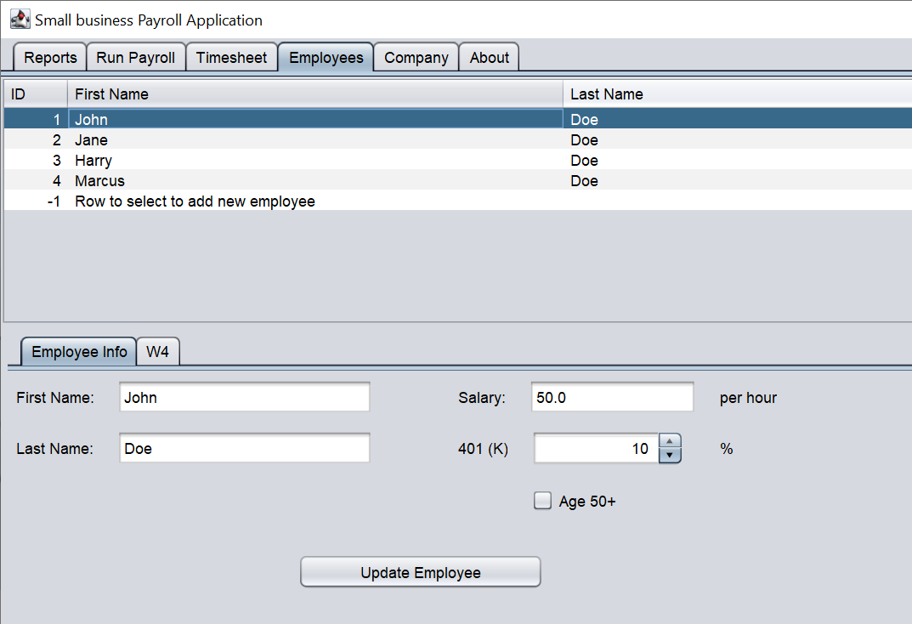
10. Select last row to add new employee and select an employee row to edit information.
11. To enter timesheet information please select ‘Timesheet” tab and click on timesheet start date.
12. 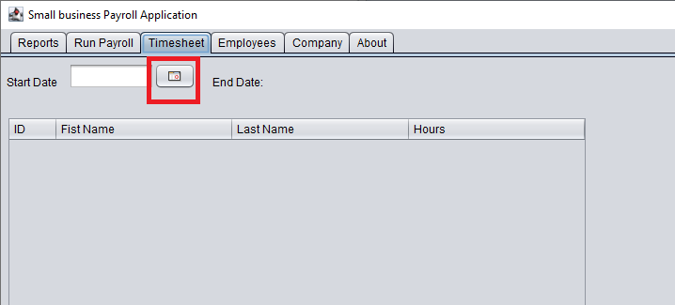
13. Select timesheet start date, the end date will be automatically updated based on the company pay period frequency. In this example the company is paying salary weekly.
14. 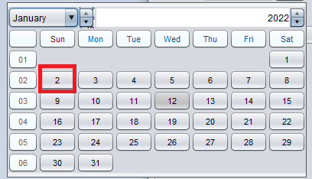
15. Update employee work hours.
16. **Important: Please hit enter to commit the changes in table grid for the last edited cell**

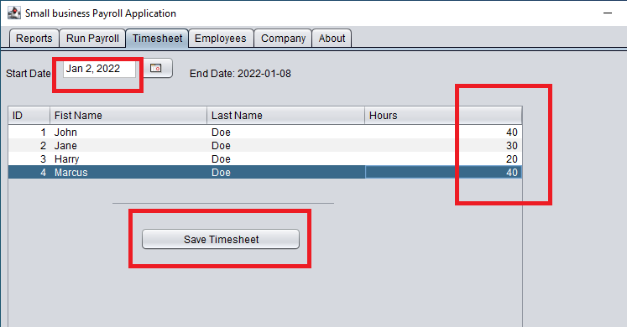

1. Press “Save Timesheet” to save the data entered.
2. Press “Run Payroll” tab to select the timesheet and pay date to pay.
3. Press “Run Payroll” to computer employee and company payroll amount

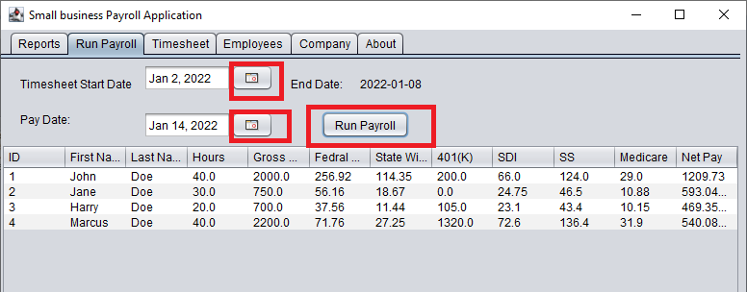

1. To print the data please select “Reports” tab; the payroll information for the calendar year will be written in CSV format file which you can open in any spreadsheet applications like Excel and do advance processing and printing. To help you in filling the payroll forms.
2. 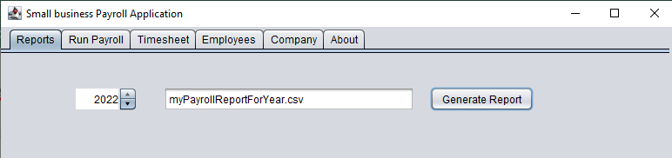

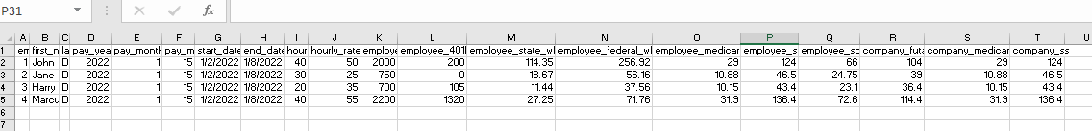

1. The cycle of entering timesheet, running payroll, generating report continues. For example, for next week the timesheet data is entered and payroll run and report produced as follows
2. 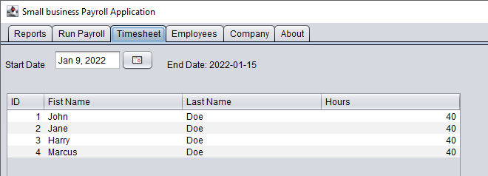
3. 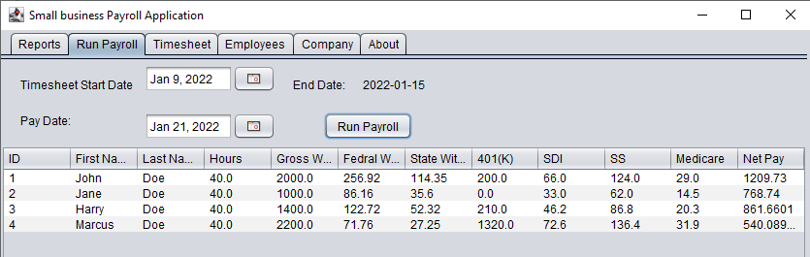

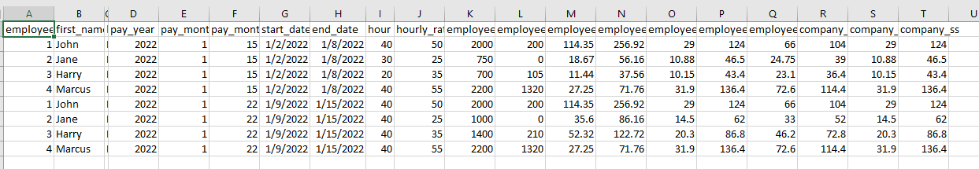

**About Payroll application**

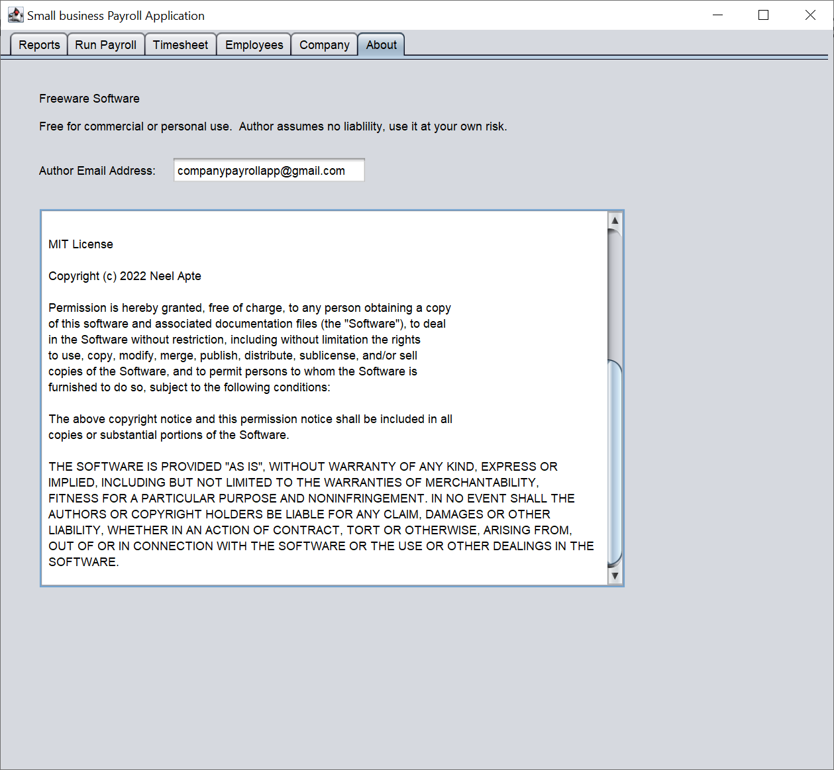

**Legal Disclaimer**

**MIT License**

**Copyright (c) 2022 Neel Apte**

**Permission is hereby granted, free of charge, to any person obtaining a copy**

**of this software and associated documentation files (the "Software"), to deal**

**in the Software without restriction, including without limitation the rights**

**to use, copy, modify, merge, publish, distribute, sublicense, and/or sell**

**copies of the Software, and to permit persons to whom the Software is**

**furnished to do so, subject to the following conditions:**

**The above copyright notice and this permission notice shall be included in all**

**copies or substantial portions of the Software.**

**THE SOFTWARE IS PROVIDED "AS IS", WITHOUT WARRANTY OF ANY KIND, EXPRESS OR**

**IMPLIED, INCLUDING BUT NOT LIMITED TO THE WARRANTIES OF MERCHANTABILITY,**

**FITNESS FOR A PARTICULAR PURPOSE AND NONINFRINGEMENT. IN NO EVENT SHALL THE**

**AUTHORS OR COPYRIGHT HOLDERS BE LIABLE FOR ANY CLAIM, DAMAGES OR OTHER**

**LIABILITY, WHETHER IN AN ACTION OF CONTRACT, TORT OR OTHERWISE, ARISING FROM,**

**OUT OF OR IN CONNECTION WITH THE SOFTWARE OR THE USE OR OTHER DEALINGS IN THE**

**SOFTWARE.**